1. Attach Pessimist to Economy

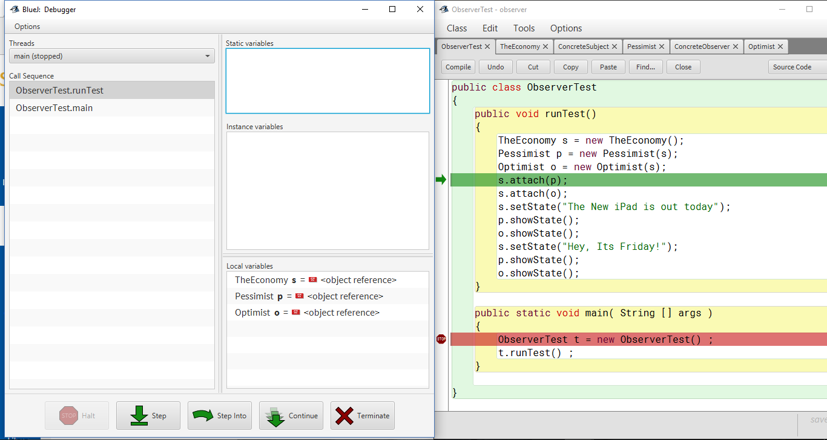

1. Initial values of objects :

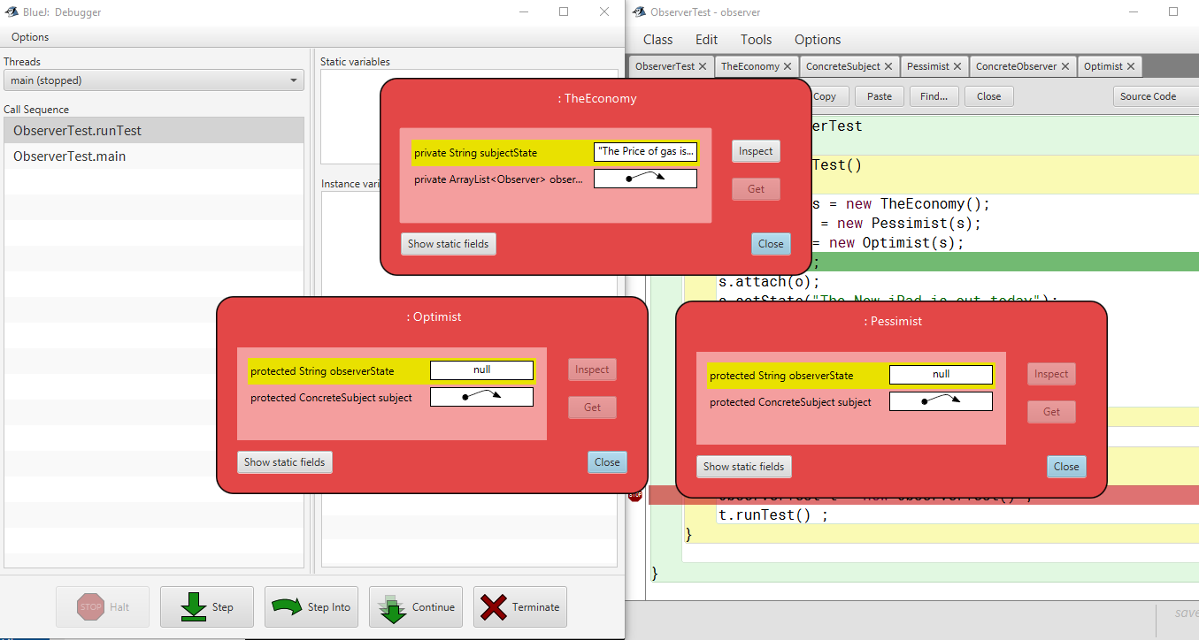

1. Attach method adds Pessimist observer to Subject’s array of observers

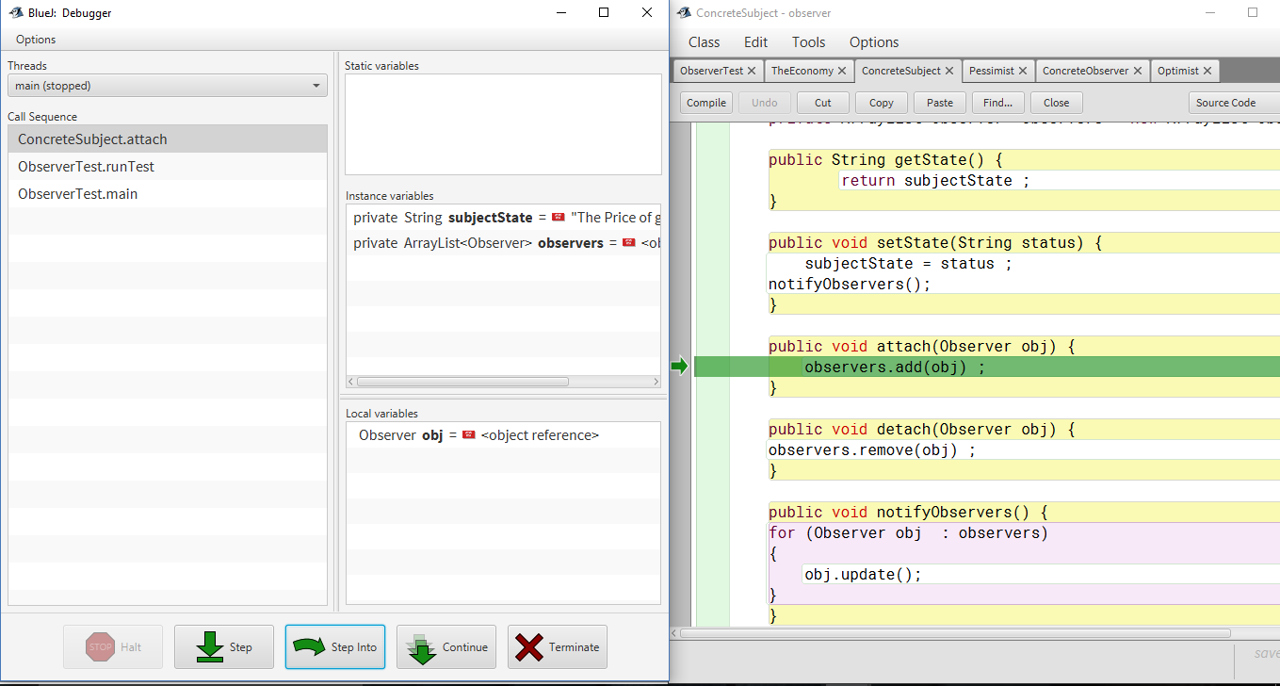

1. Add optimist observer to Economist Subject

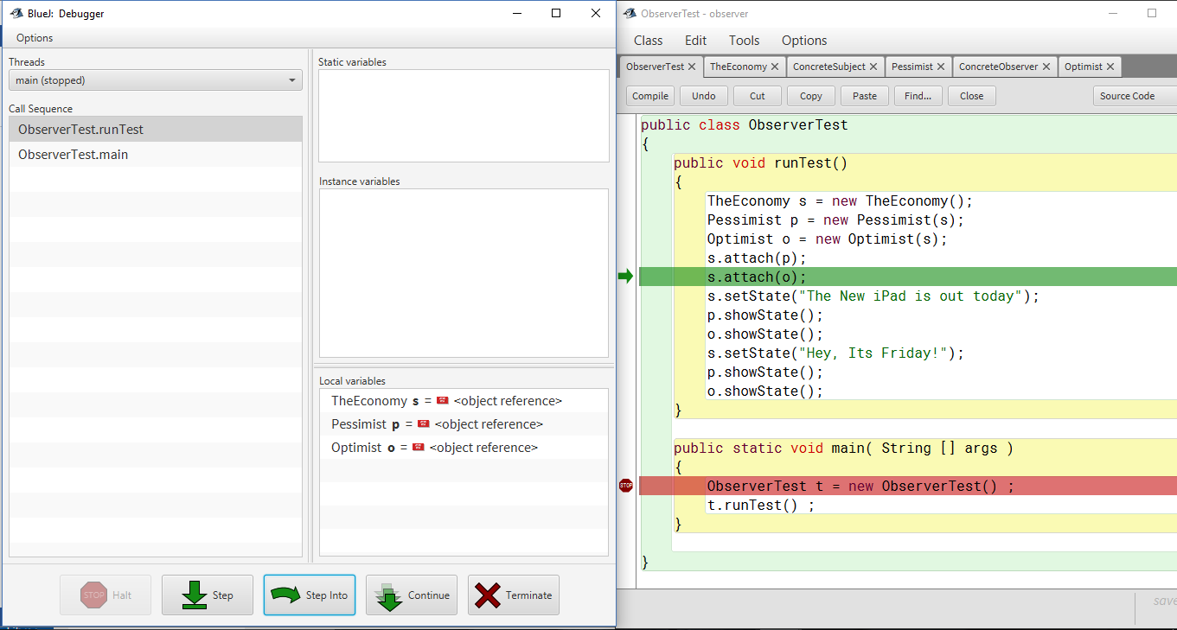

1. Attach method adds Optimist observer to Subject’s array of observers

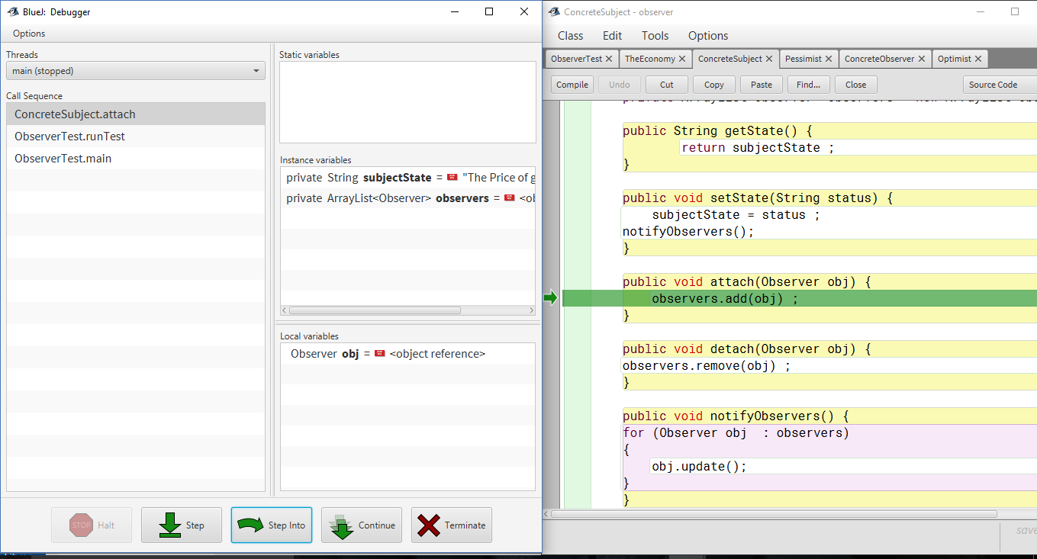

1. After attaching both the observers, state of Economist :

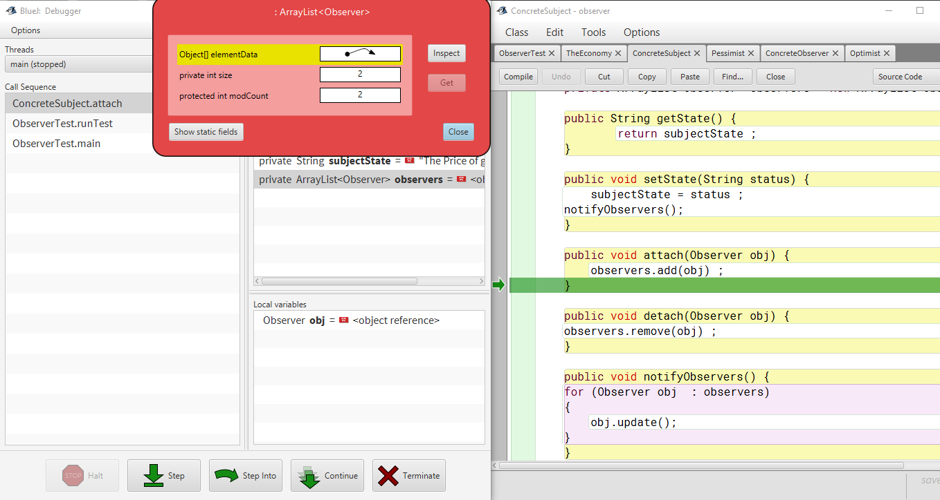

1. Set State of subject :

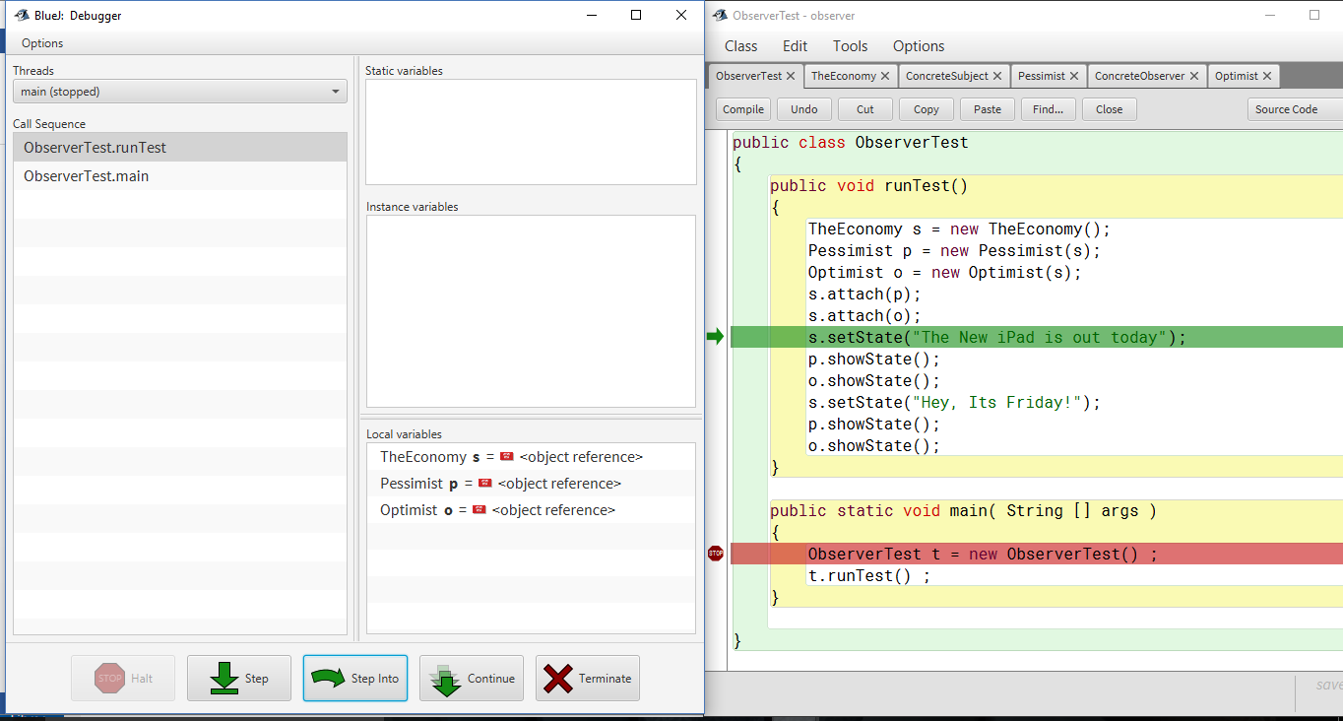

1. setState method of TheEconomy sets value of variable State to passed String

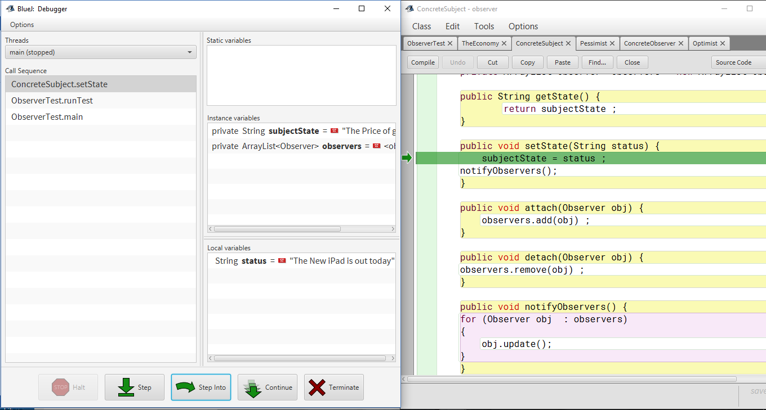

Debugging Observer Pattren:

1. runTest() method is called from ObserverTest class

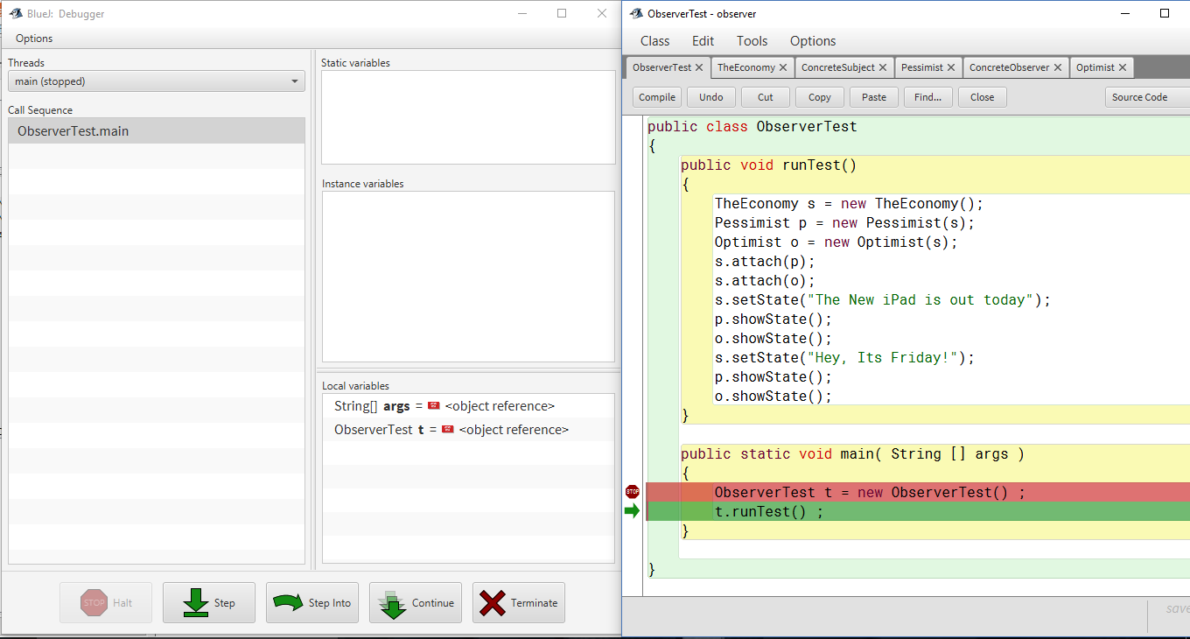

1. Attaching Pessimist observer to subject TheEconomy which will add this pessimist object to its ArrayList observers.

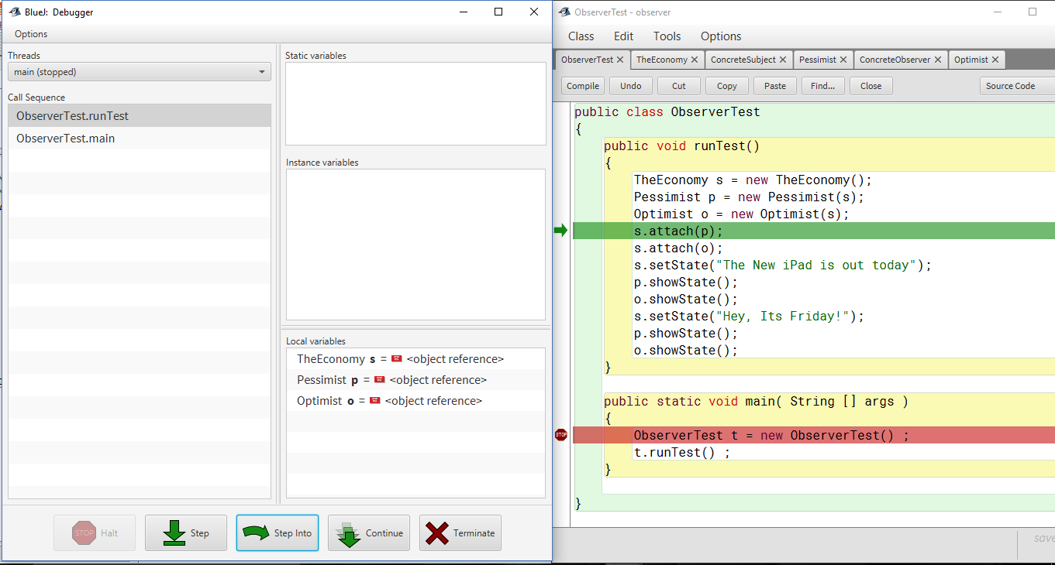

Attach Method Call of Concrete Subject:

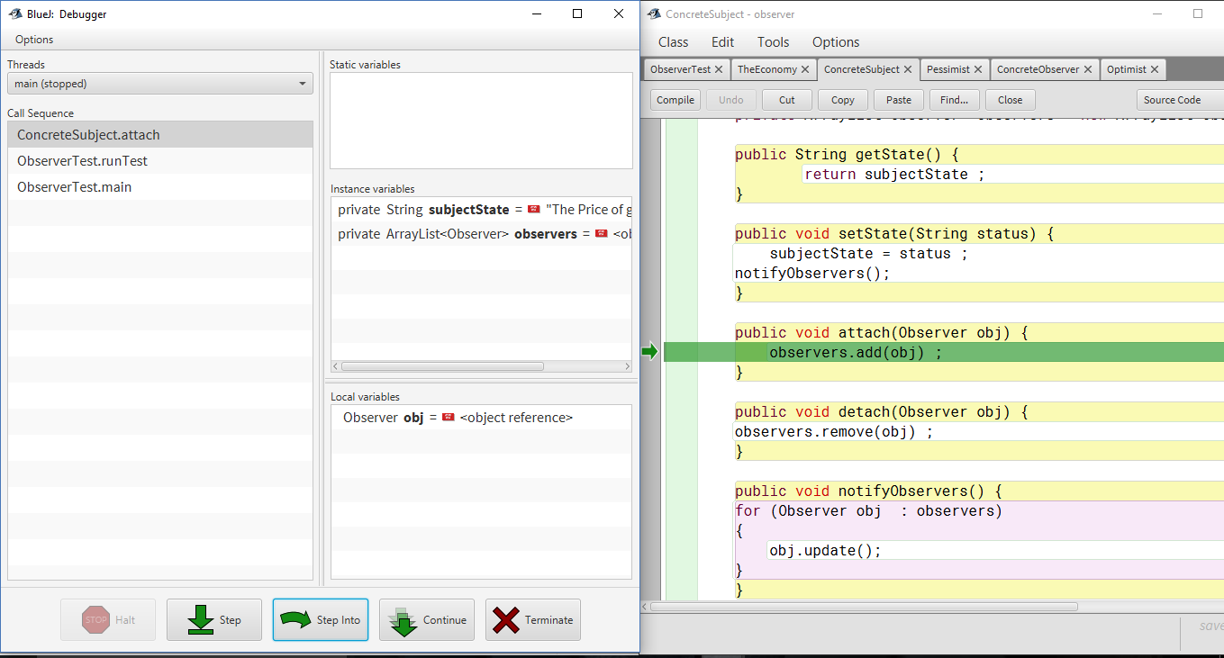

1. Attaching Optimist observer to subject TheEconomy which will add this optimist object to its ArrayList observers.

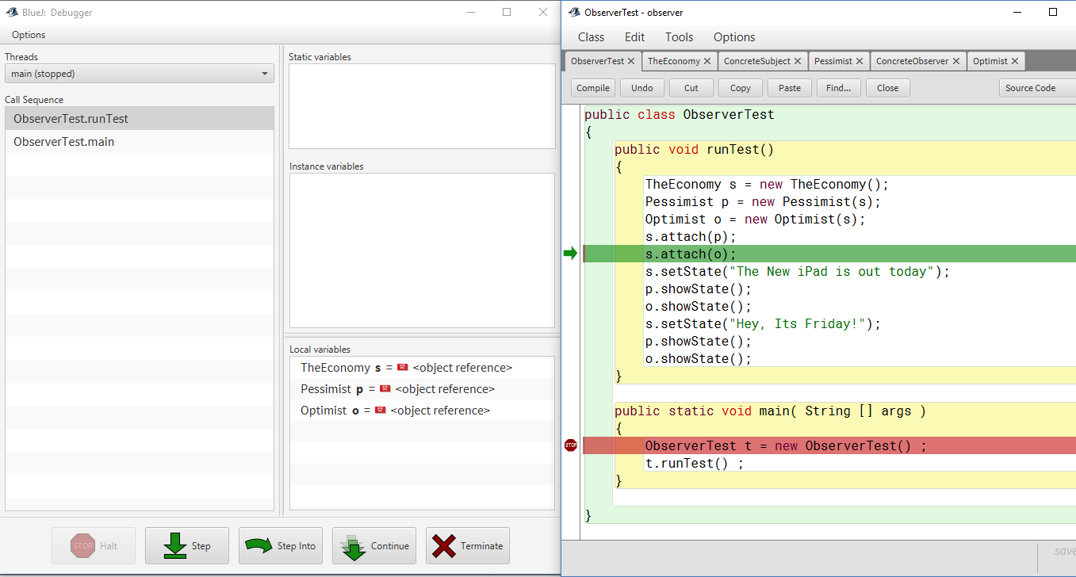

Attach Method Call of Concrete Subject:

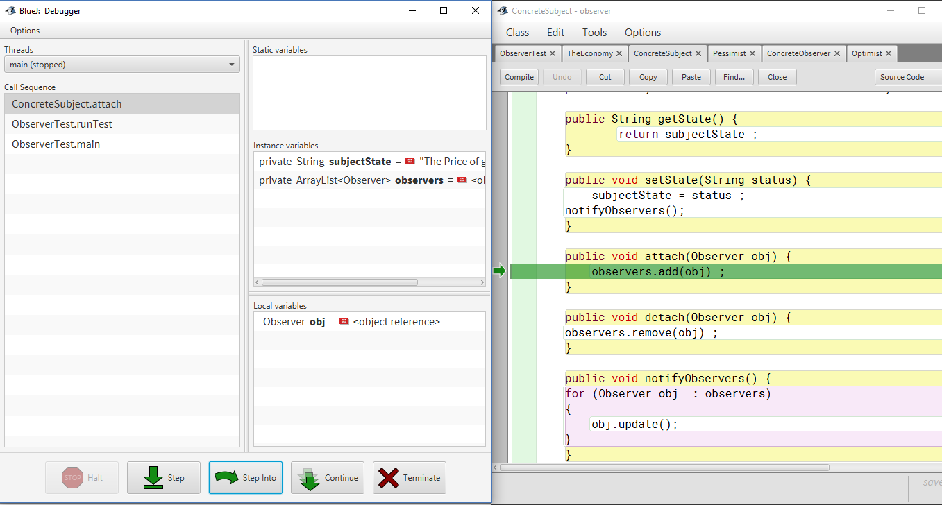

1. Call setState method on Subject which will set subjectState to String “The New iPad is out today”.

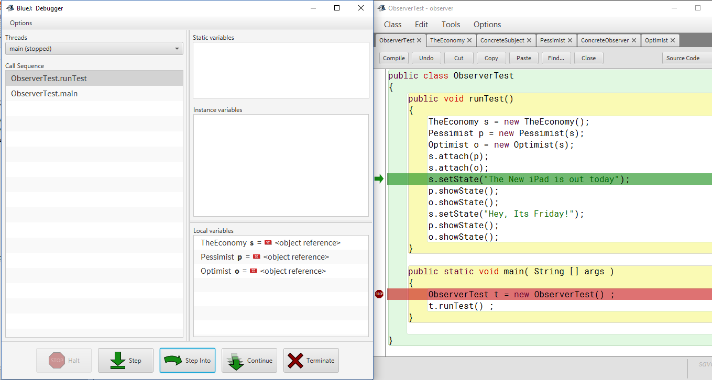

* 1. setState method calls notifyObservers to notify all the observers which are in ArrayList that state of subject has been changed.

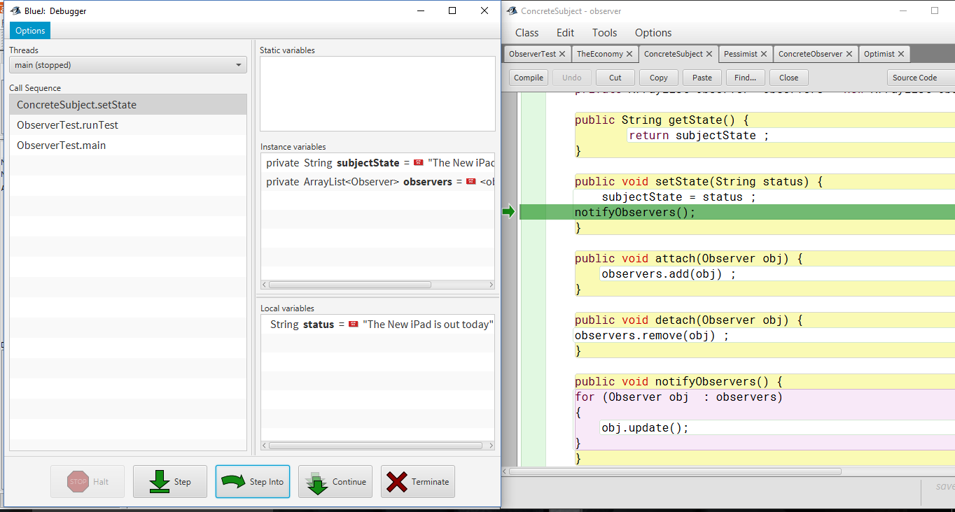

notifyObservers() calls update method of each of the observer which were added.

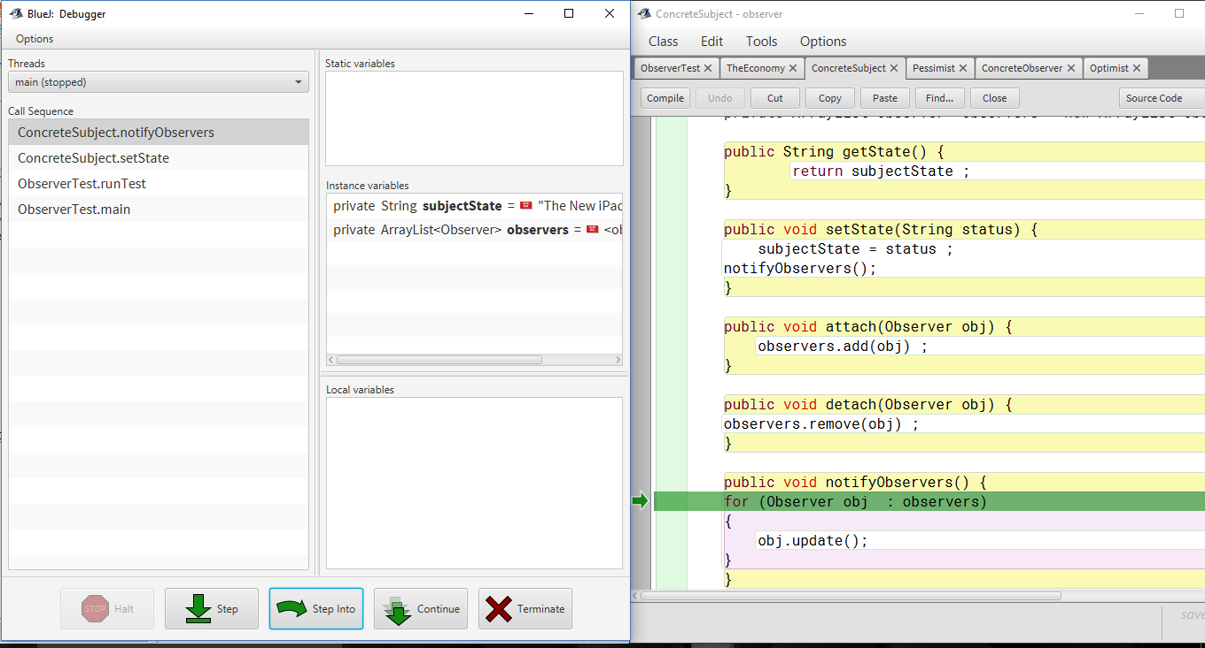

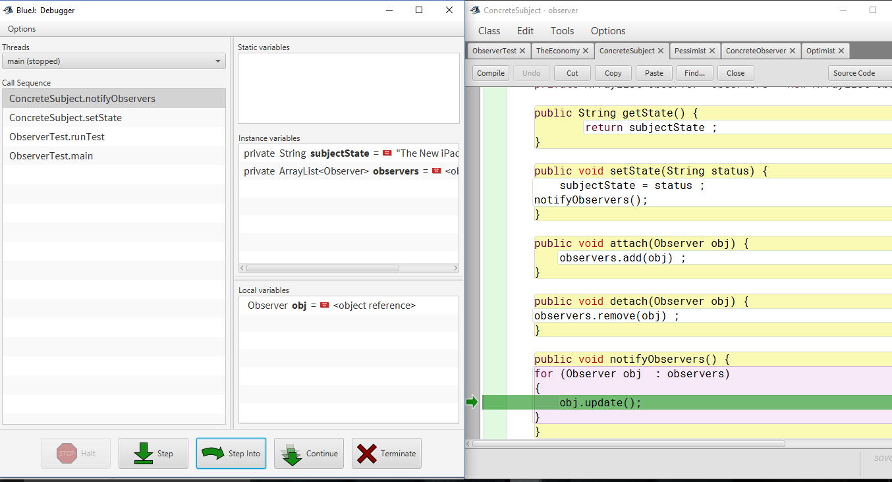

* 1. Call on update method of Pessimist observer

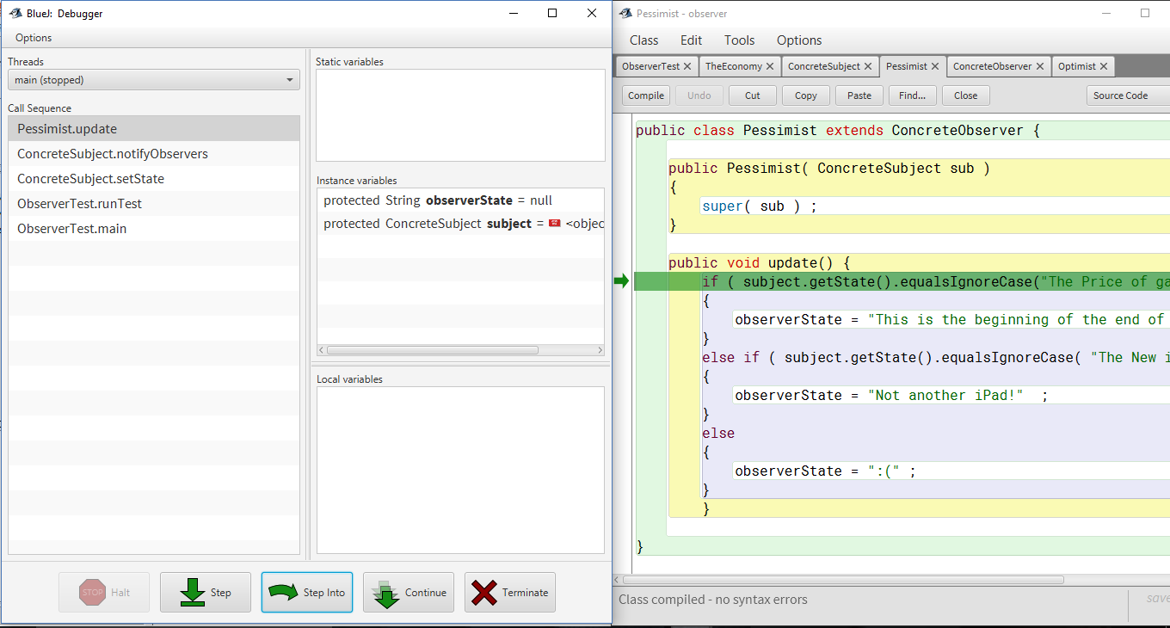

1. Update method calls getState() of subject to get value of current state in if condition.

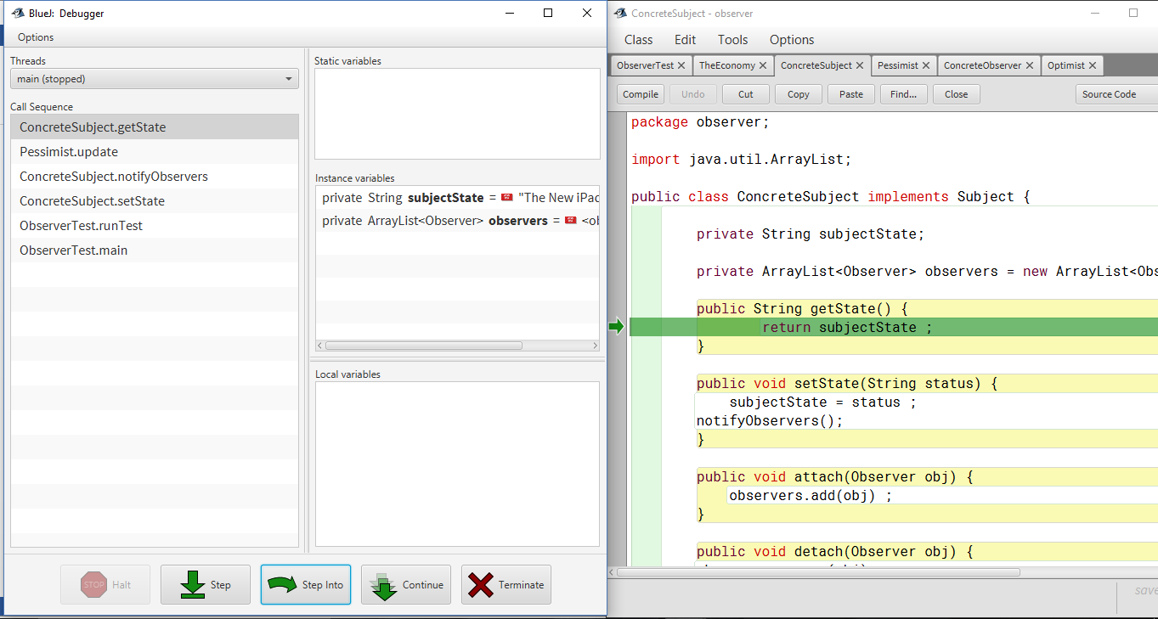

1. Update method calls getState() of subject to get value of current state in else if condition.

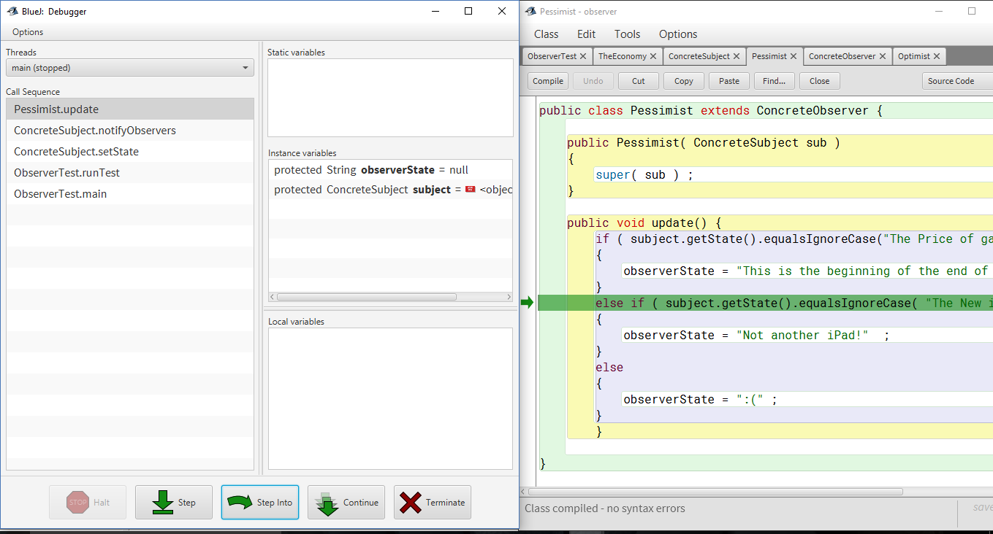



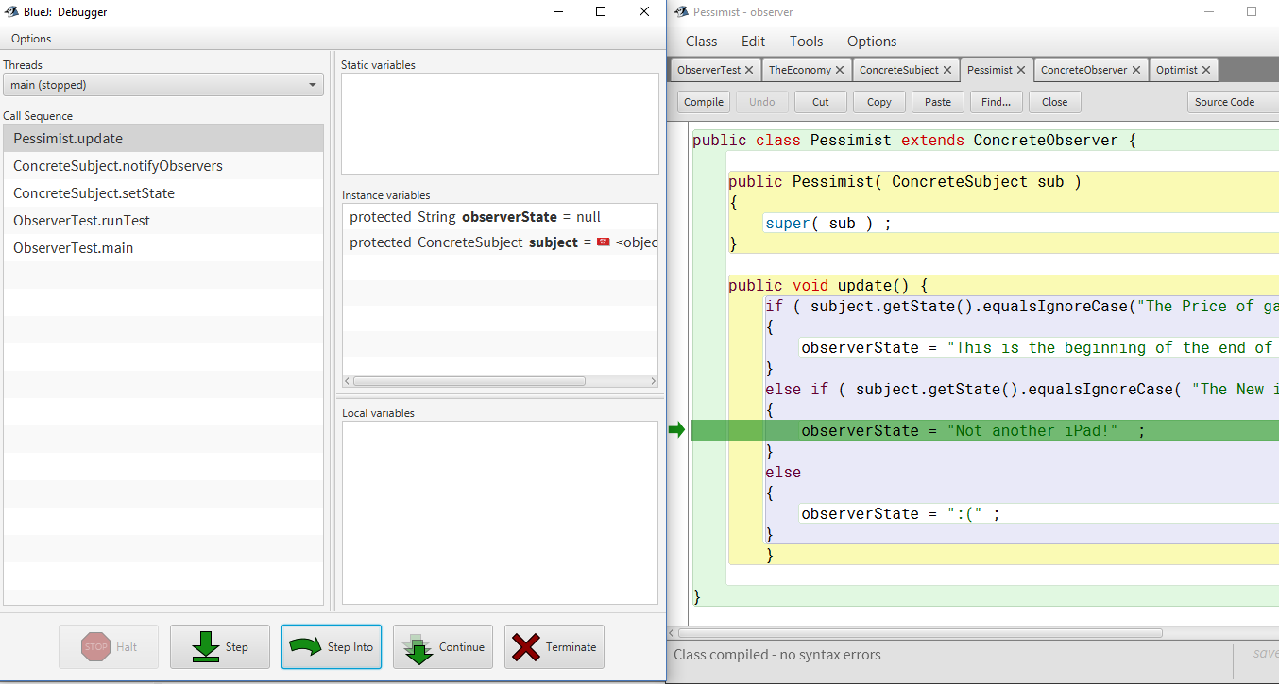

1. Call on update method of Optimist observer

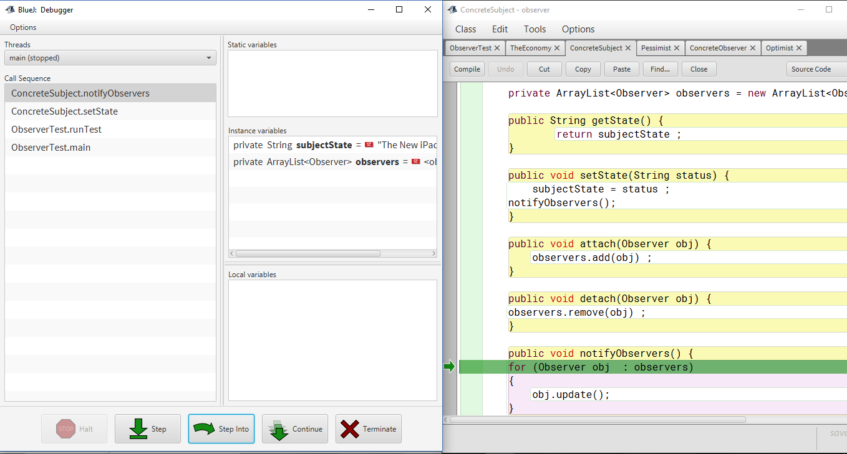

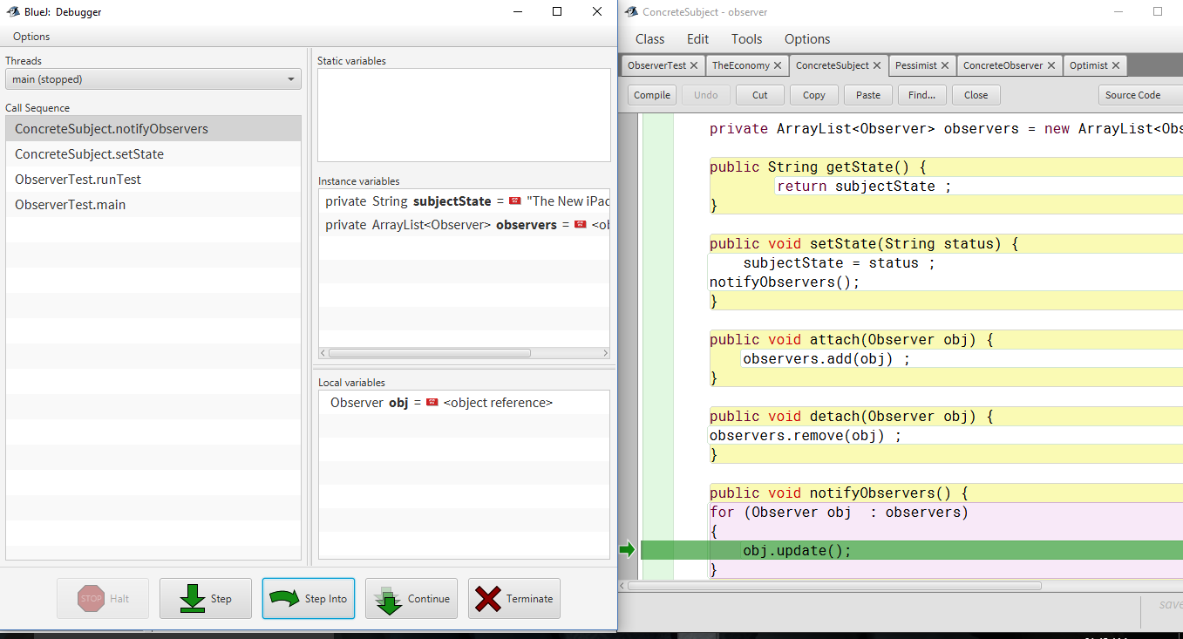

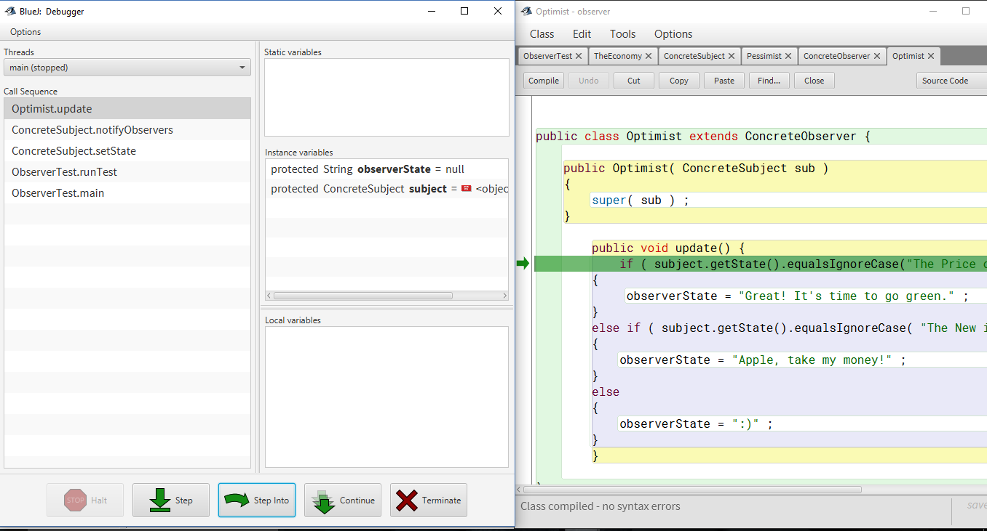

* 1. Update method calls getState() of subject to get value of current state in if condition.

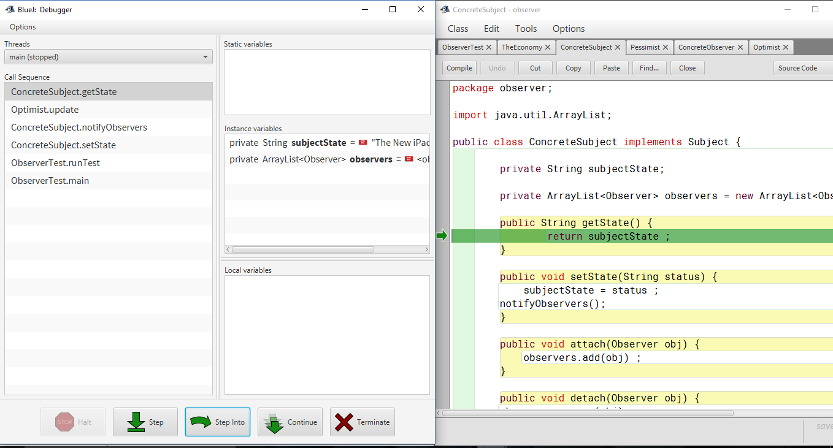

1. Update method calls getState() of subject to get value of current state in else if condition.

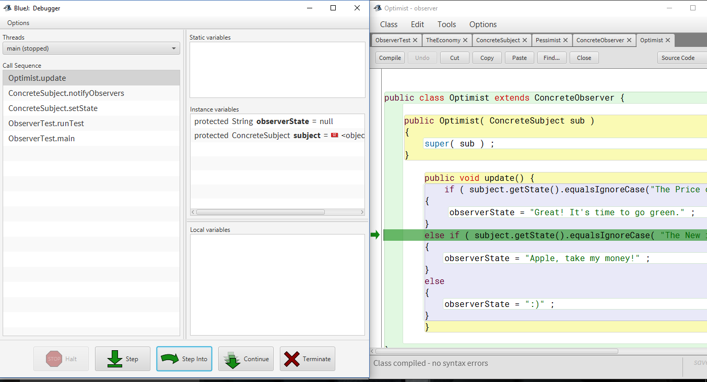

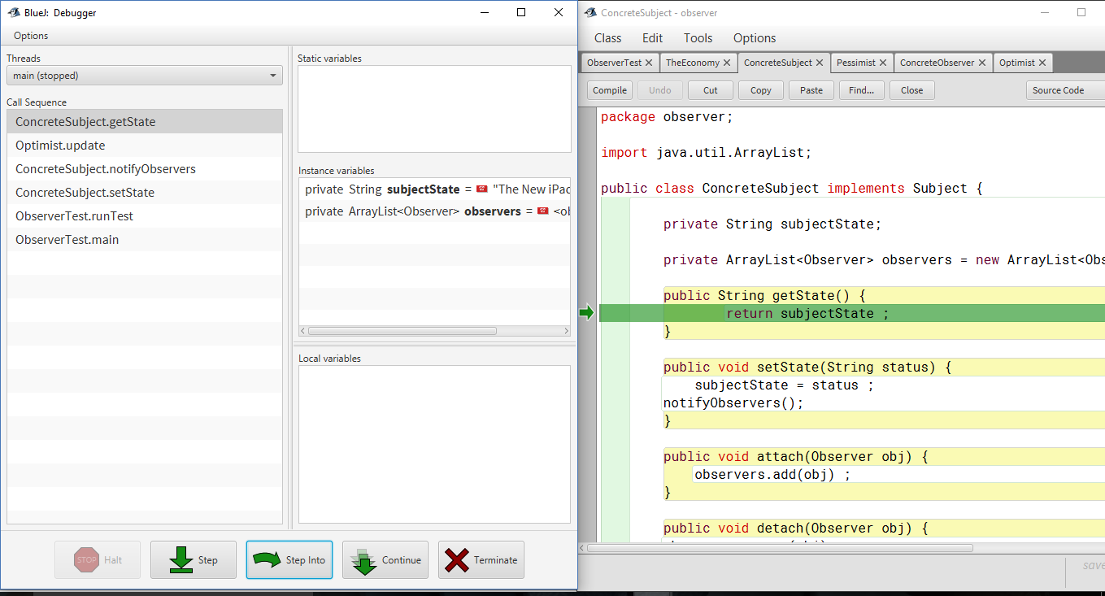

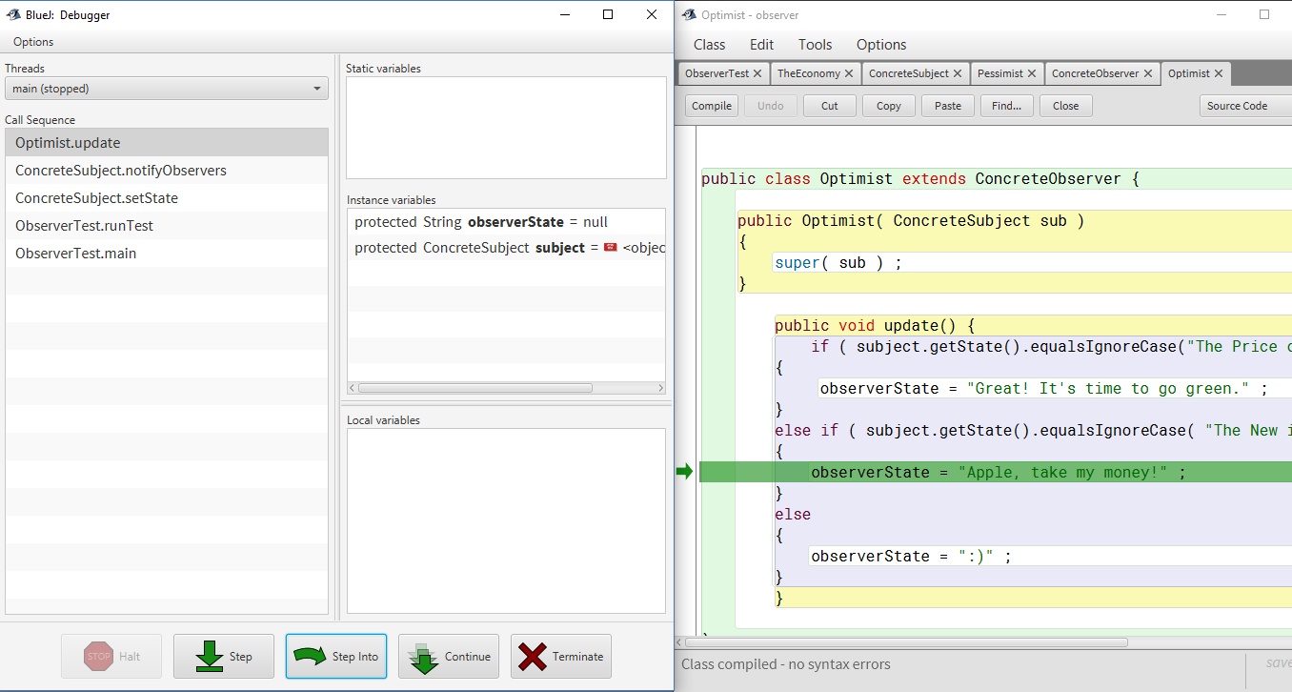

1. showState() method of Pessimist observer is called which displays its state.

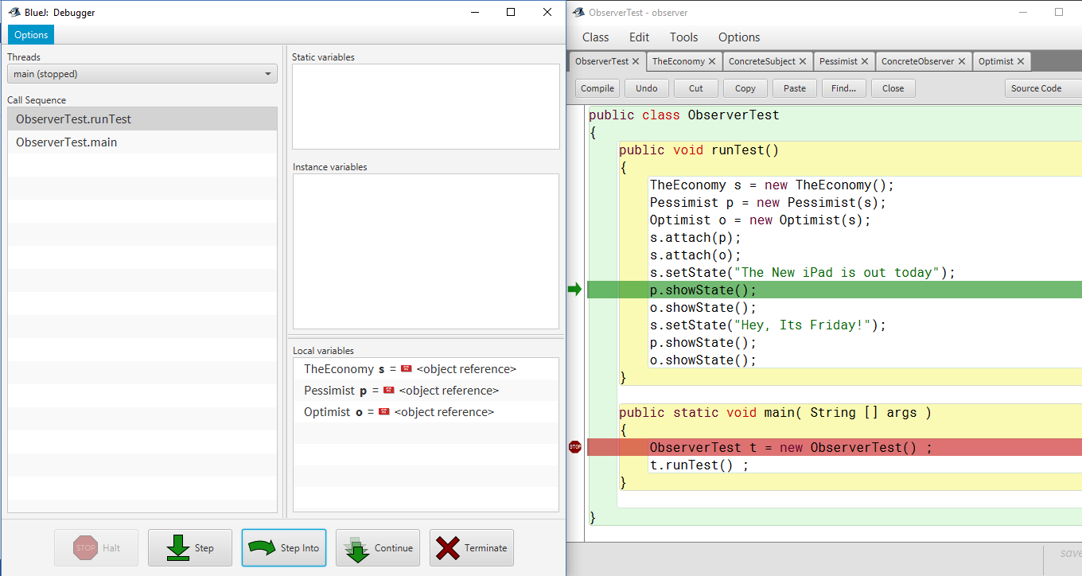

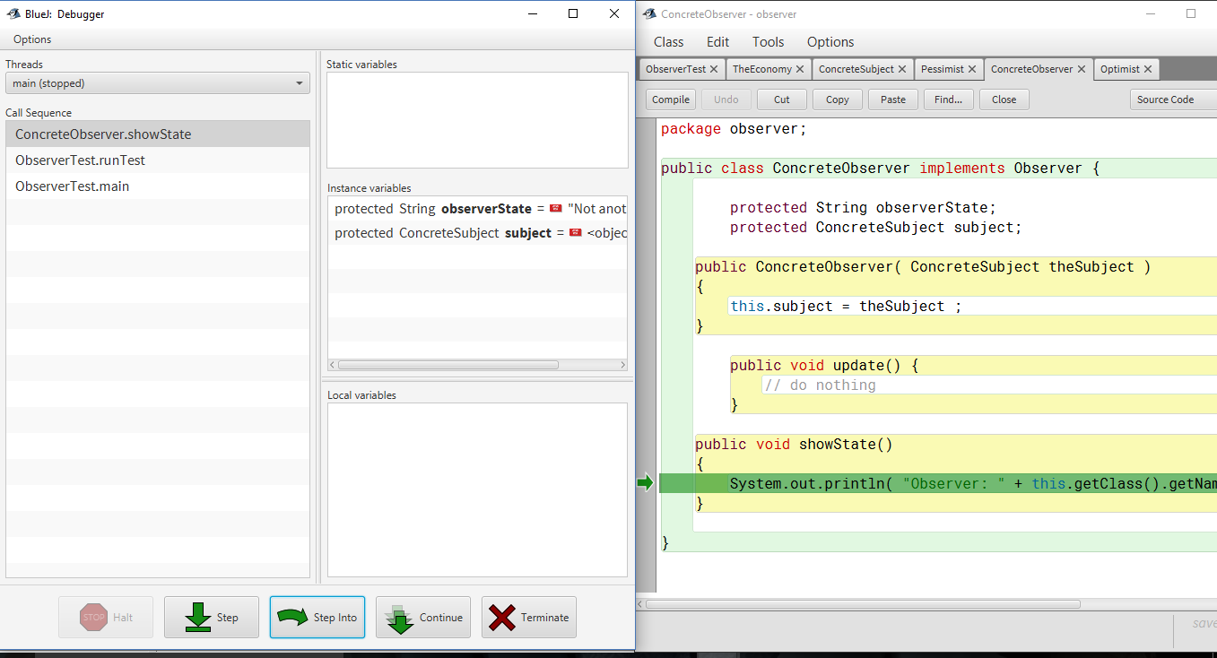

1. showState() method of Optimist observer is called which displays its state.

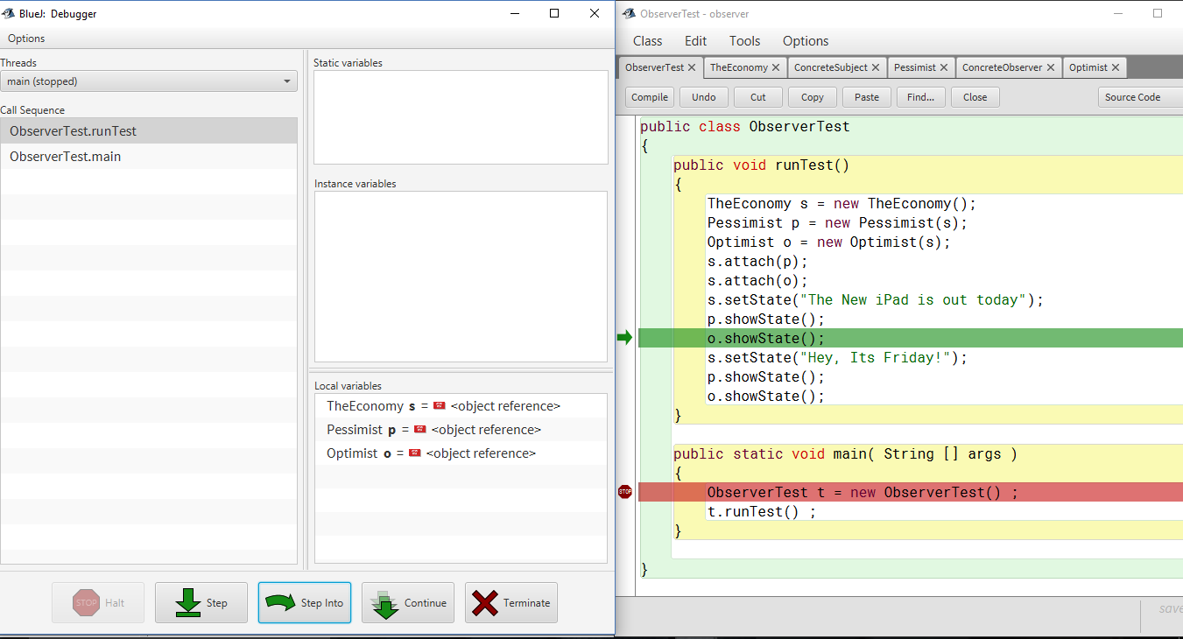

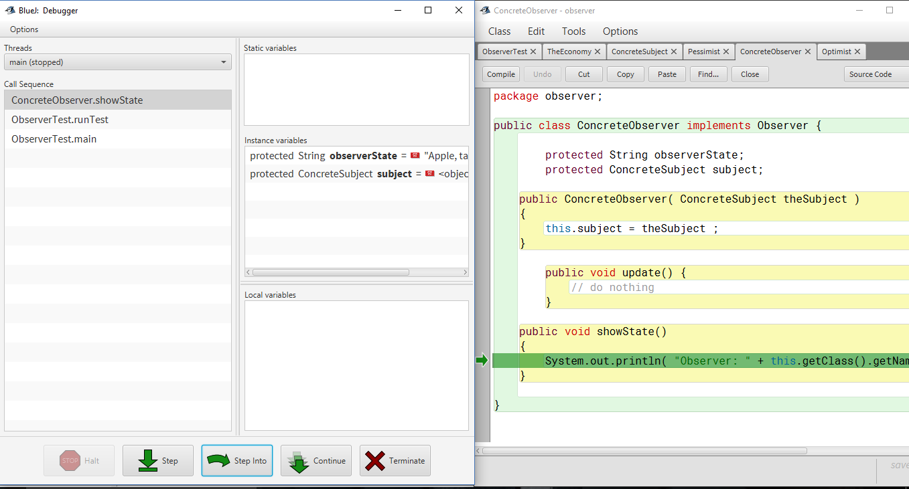

1. Call setState method on Subject which will set subjectState to String “Hey, Its Friday !”.

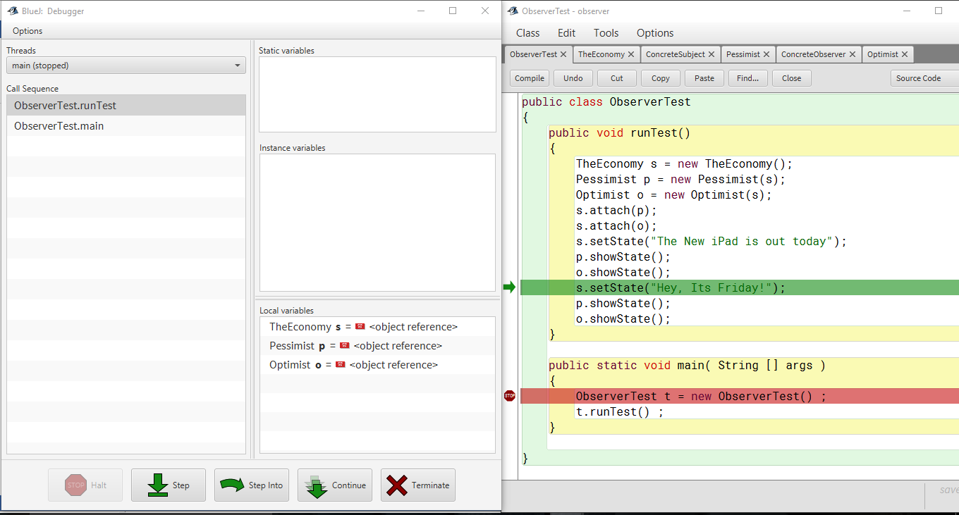

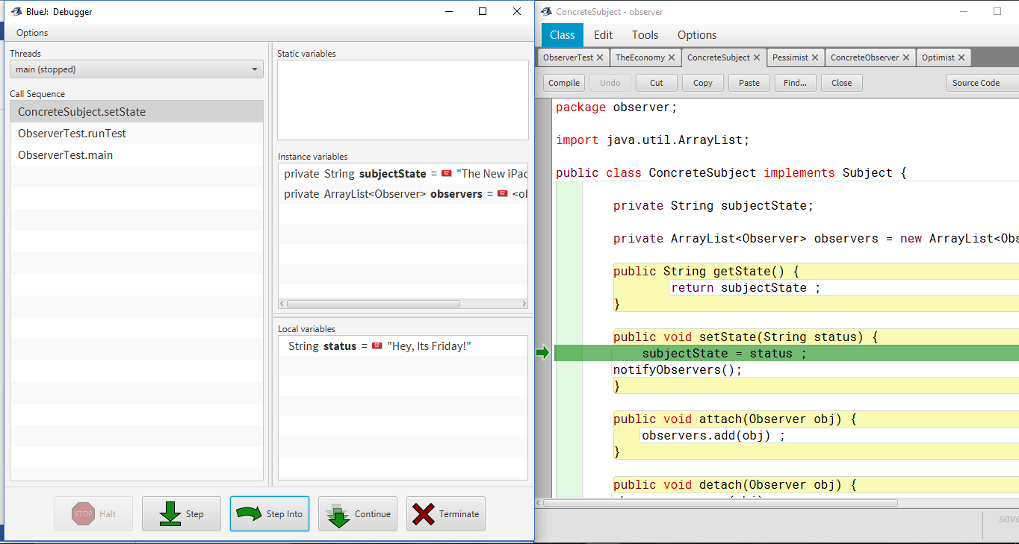

* 1. setState method calls notifyObservers to notify all the observers which are in ArrayList that state of subject has been changed.

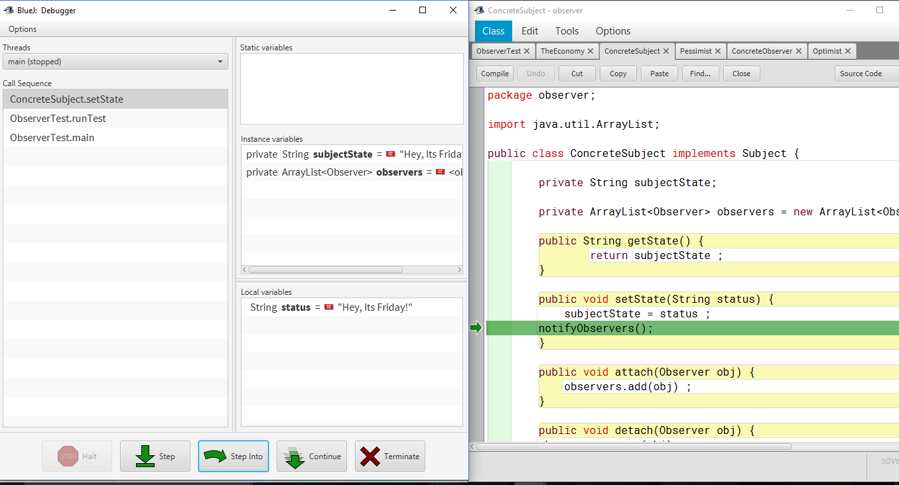

notifyObservers() calls update method of each of the observer which were added.

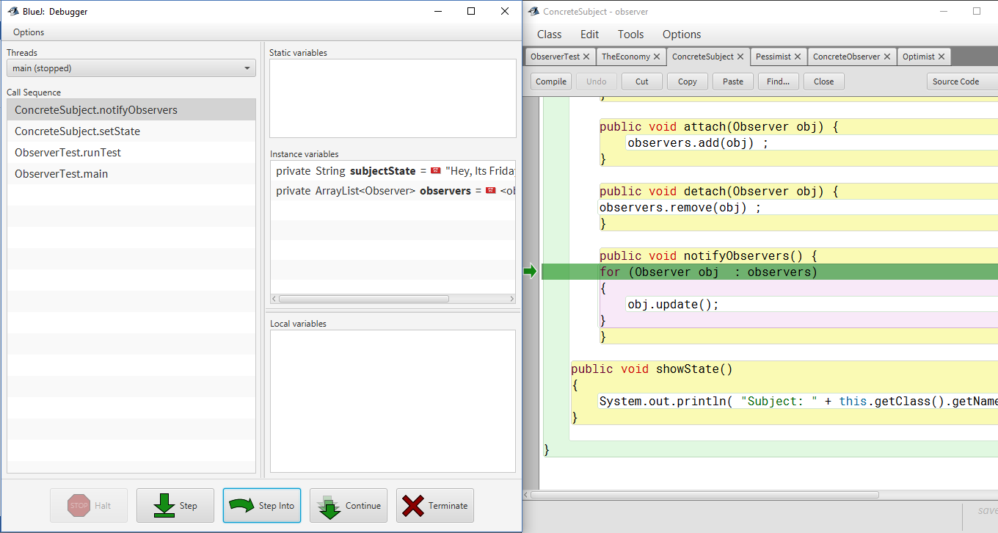

* 1. Call on update method of Pessimist observer

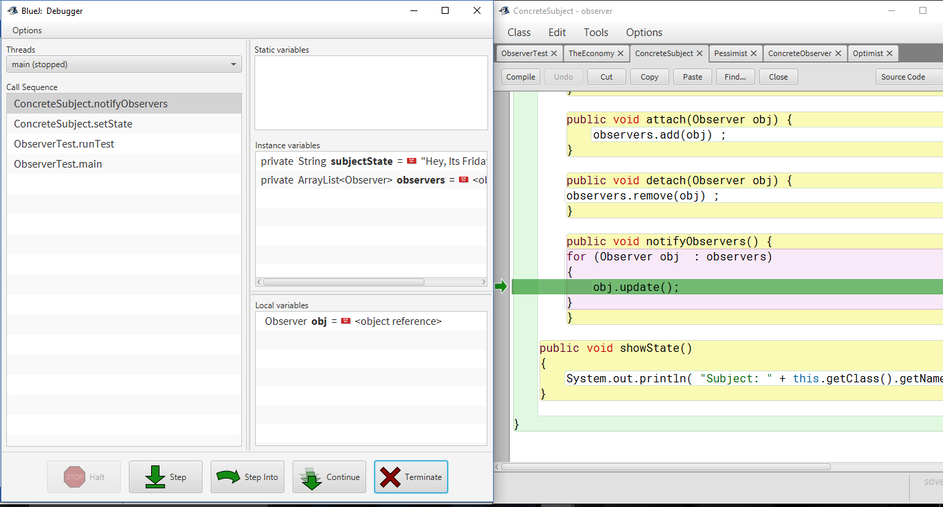

* + 1. Update method calls getState() of subject to get value of current state in if condition.

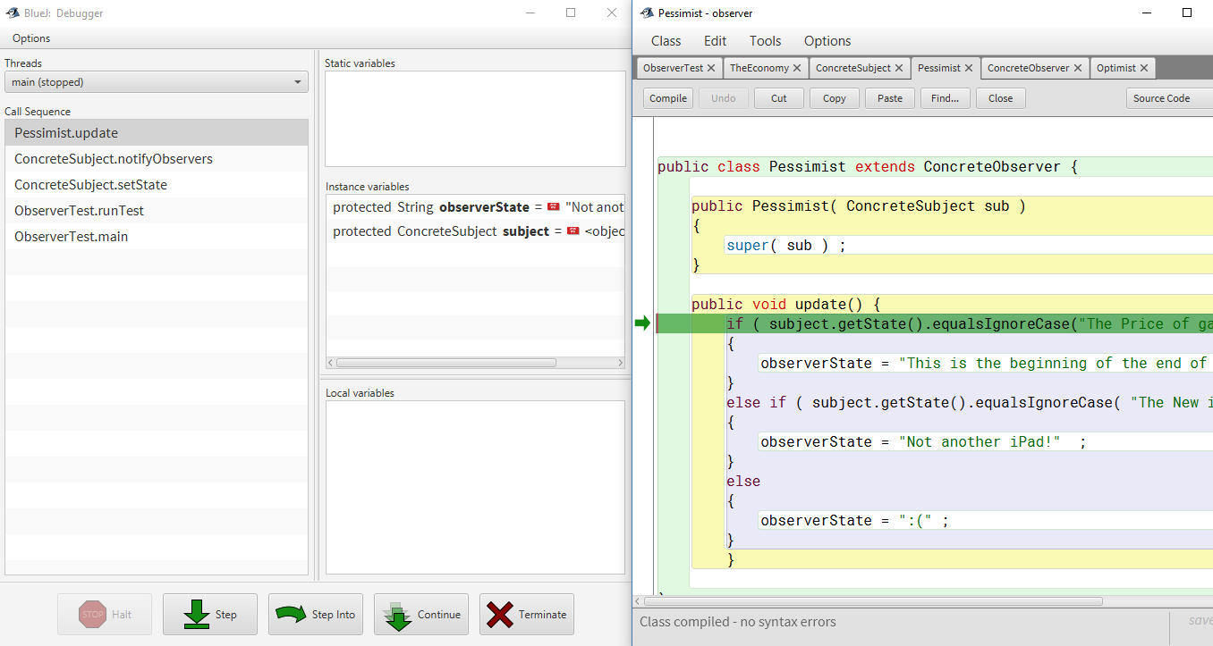

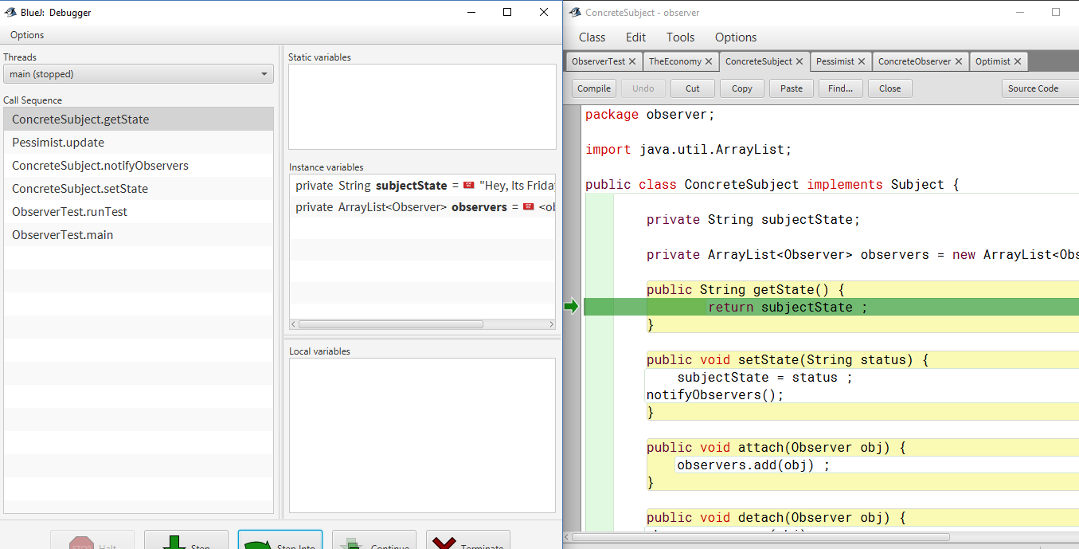

* + 1. Update method calls getState() of subject to get value of current state in else if condition.

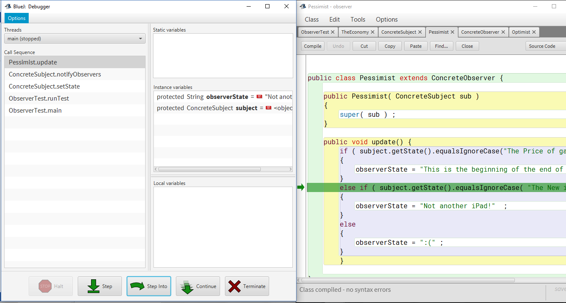

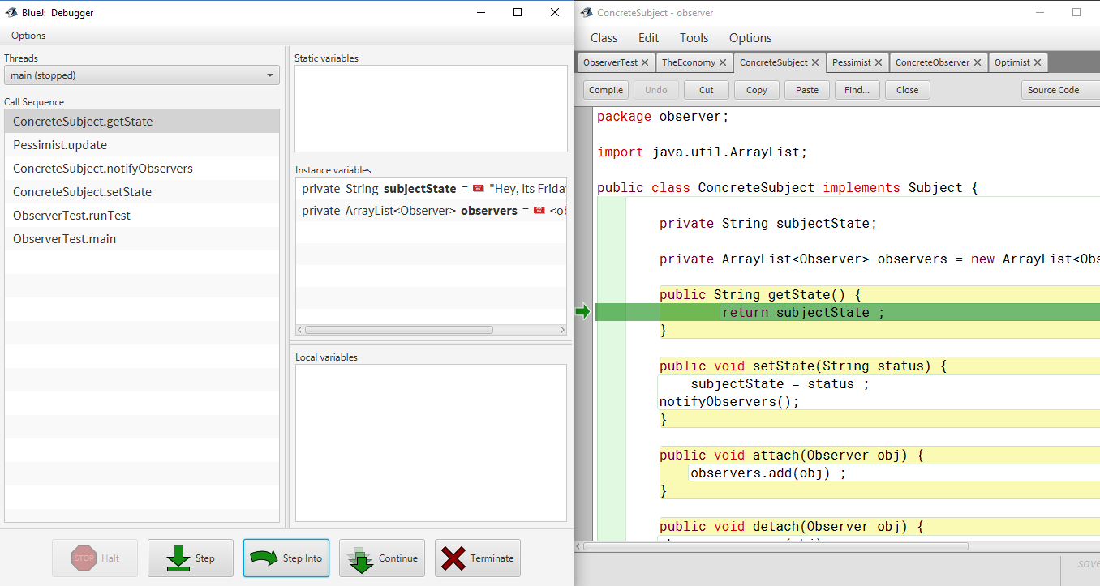

* 1. Call on update method of Optimist observer





* + 1. Update method calls getState() of subject to get value of current state in if condition.





* + 1. Update method calls getState() of subject to get value of current state in else if condition.

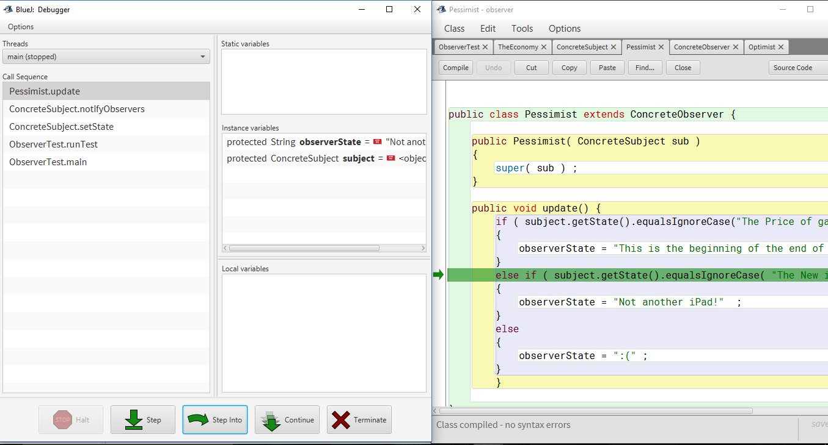



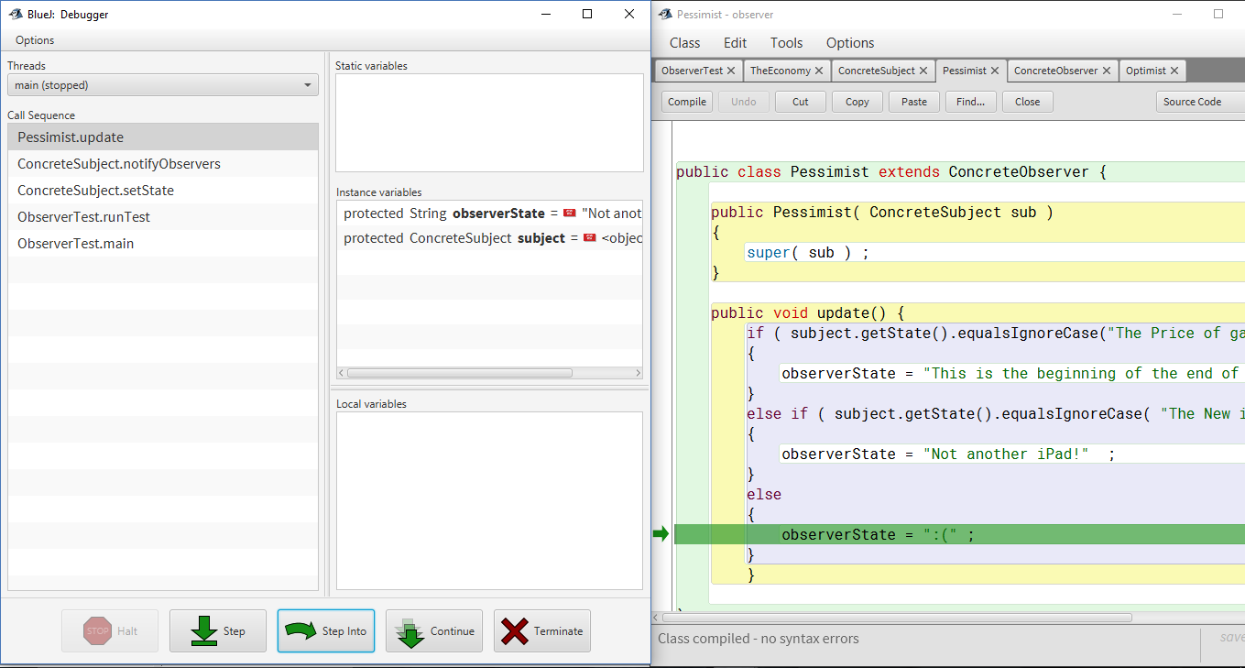

1. showState() method of Pessimist observer is called which displays its state.
2. showState() method of Optimist observer is called which displays its state.